**HOW TO SET UP THE PARTICLE DETECTOR PROJECT**

**Giorgia Mazzini**

**Matilde Mazzini**

**Florine Valcher**

**University of Hawaii at Manoa, 2017**

**Part List:** Here are some the things you need to build your Particle Detector!

|  |  |  |  |
| --- | --- | --- | --- |
| **Description** | **Unit Cost** | **Vendor** | **Link** |
| **Micro SD** card at least 8 Gb class 10 | $12,99 | Best Buy | <http://www.bestbuy.com/site/sandisk-ultra-8gb-microsdhc-uhs-i-class-10-memory-card-gray-red/5577759.p?skuId=5577759> |
| **Adapter** Micro SD to SD | $6,99 | Amazon | <https://www.amazon.com/Adapter-Standard-Connector-Smartphones-Function/dp/B01BXSKPES/ref=sr_1_4?s=pc&ie=UTF8&qid=1489542940&sr=1-4&keywords=sd+adapter> |
| **Raspberry Pi 3 - Model B** - ARMv8 with 1G RAM AND built-in WiFi | $39,95 | Adafruit | <https://www.adafruit.com/product/3055> |
| **5V 2.4A Switching Power Supply** w/ 6' MicroUSB Cable | $7,50 | Adafruit | <https://www.adafruit.com/product/1995> |
| **USB Logitech c270 Webcam** | $19,99 | Best Buy | <http://www.bestbuy.com/site/logitech-hd-webcam-c270-black/9928354.p?skuId=9928354> |
| Plugable USB 2.0 4-Port High Speed **Charging Hub** (power supply+ cable hub to USB are going to be inside) | $16,95 | Amazon | <https://www.amazon.com/Plugable-Charging-Adapter-Support-Android/dp/B005P2BY5I/ref=cm_cr_arp_d_product_top?ie=UTF8> |
| **Adafruit Parts Pal**  Where you can find:  -Green and Red LED 5mm  -Tactile Button switch (6mm)  -Breadboard  -560 ohm 5% axial resistors (x2)  - Male/Male Jumper Wires 6’’ (x6) | $19,95 | Adafruit | <https://www.adafruit.com/products/2975> |
| **Adafruit Assembled Pi Cobbler Plus with GPIO Ribbon Cable** for Raspberry Pi Model A+/B+/Pi 2/Pi 3 - (40 pins) | $6,95 | Adafruit | <https://www.adafruit.com/products/2029> |
| **Ultimate GPS Breakout**  With externa antenna | $39,95 | Adafruit | https://www.adafruit.com/product/746 |
| **Active buzzer**  PCB Piezo Buzzer  12 VDC 70dB | $8,49 | Radio Shack | https://www.amazon.com/dp/B001VLJQGG/ref=asc_df_B001VLJQGG5072241/?tag=hyprod-20&creative=395033&creativeASIN=B001VLJQGG&linkCode=df0&hvadid=167135564802&hvpos=1o1&hvnetw=g&hvrand=7550471316602370149&hvpone=&hvptwo=&hvqmt=&hvdev=c&hvdvcmdl=&hvlocint=&hvlocphy=9060110&hvtargid=pla-309377717751 |
| **BMP 180**  Pressure + Temperature Sensor | $6,99 | JBtek | https://www.amazon.com/JBtek-Barometric-Pressure-Temperature-Altitude/dp/B00UUS12PO/ref=sr_1_1?ie=UTF8&qid=1498617279&sr=8-1&keywords=BMP+180+sensor |
| **Monochrome 128x32 I2C OLED** | $17,50 | Adafruit | https://www.adafruit.com/product/931 |

**Parts you need for the improvement**

You will also need:

Monitor + cable: Monitor port to HDMI (Raspberry Pi port)

USB Keyboard and mouse

But you can find those wherever you want.

In this documentation, there are two versions. The first one is a simpler version which allows you to detect particles and to display in the Terminal the number of events you detected. You also have a GPS module which allows you to know the location of the experiment.

The second version is an improvement of the first one, where you add different sensors like temperature and pressure sensors, a display screen, a more powerful GPS Module, and a buzzer.

For both versions, follow the beginning of this tutorial.

Note that if you use the first version (you only use a webcam and a GPS), you will need to run this program: **particledetectorGM.py**.

If you want to use the full version, with all the sensors, you have to run the program: **ParticleDetectorImproved.py**.

You can find these files on a USB key. Ask Dr. Bindi or Davin Sasaki.

**THE RASPBERRY PI:**

The **Raspberry Pi** is a small single-board computer developed to promote the teaching of basic **computer science** in schools.

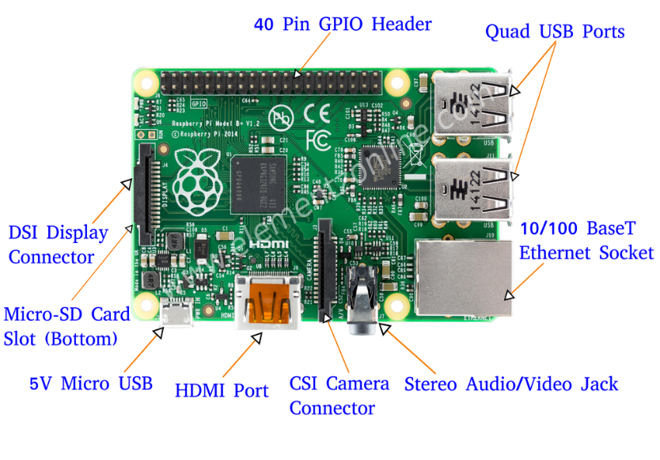

http://beliketechies.blogspot.com/

**Installation Guide:** You can follow these steps in order to have a working Raspberry Pi.

If an error occurs, the steps that you need to follow are:

* Double-check the spelling.
* Check that your Wi-Fi is on and you are able to surf the net!
* Try again.

**Setting up SD:** First thing you need to do is to prepare your SD card installing on it the OS(Operating System).

Insert the SD in your computer (it is a Micro SD, maybe your computer needs an adaptor!).

IF YOUR SD IS NEW/EMPTY/ALREADY FORMATTED YOU CAN START FROM THE INSTALLATION OF THE OPERATING SYSTEM. (Just jump the next step!)

ONLY IF YOUR SD IS NOT NEW/EMPTY/ALREADY FORMATTED YOU WILL NEED TO:

Download and Open “SD formatter” from https://www.sdcard.org/downloads/index.html

In Options choose: Full (erase) and Size adjustment on.

In “drive” be sure to choose the right device (you can always investigate before formatting something you don’t want to ;) ) that has to be formatted.

Format SD.

IF YOUR SD IS NEW/EMPTY/ALREADY FORMATTED YOU CAN START FROM HERE.

**Install Operating System:** Now you need to install the Raspberry OS on the SD that you just formatted.

From <https://www.raspberrypi.org/downloads/raspbian/>

Download Raspbian Jessie (NOT lite) 1.5 Gb.

Unzip it. Download and open Win 32 Disk Imager from https://sourceforge.net/projects/win32diskimager/

Load Raspbian Jessie image. Choose the right device where to save the OS (the SD card). Write - Yes.

Now your SD with the Raspberry Pi OS is ready! Insert it in your Raspberry Pi.

(Sometimes the installation of Raspbian will create a strange partition in your SD but we will tell you how to fix this problem few steps later!)

**Setting up the RSB:**

Connect Raspberry to Monitor+Keyboard+Mouse. Connect it to power and wait for it to switch ON.

It can ask for a **Password: raspberry (login: pi)** IMPORTANT: When you type your password you will not see anything!!Just type and press Enter.

…Here is your Raspberry Pi: before starting to configure it you can take a look to all its features like installed programs or games!!

We are going to say to Raspberry what to do using LXTerminal: it is a prompt where you insert commands to the Raspberry Pi.

Remember that it is sensitive to capital letters and spaces, type all commands with care ☺

Open LXTerminal and type: sudo raspi-config

From here you can:

Change your password (do it because ‘raspberry’ is common to every Raspberry!!)IMPORTANT: When you type your password you will not see anything!!Just type and press Enter.

Advanced options. Expand file system. Reboot. (There we are!! You have now fixed the partition problem we told you about, that shows up during the installation of OS. This command will let you use the whole SD card.)

**Configuring Wifi**:

It should work by itself (eventually just insert Wi-Fi password as on a normal computer or choose the right connection from the Wi-Fi icon in the top right).

You can change it if needed: Language/Country/Timezone/Keyboard just navigating here :

Start Panel. Preferences. Raspberry Pi Configuration.

Before moving on we suggest to update and upgrade your Raspberry. (We also suggest you to do it once or twice a week).

LXTerminal: sudo apt-get update

LXTerminal: sudo apt-get upgrade (can take up to 3 hours)

(you need to be connected to Wi-Fi in order to do this 2 steps)

Always reboot Raspberry after upgrading.

**Part 1: Start with the particle detector**

**Setting up the Webcam:**

Connect the USB Hub to Power and to Raspberry Pi.

Connect the USB cable of the Webcam to the USB Hub.

Enable Serial from the Start panel (the symbol is a raspberry ;) ) of Raspberry. Preferences. Raspberry Pi Configuration. Interfaces.

To check if it works install SimpleCV and do the following steps.

Install **SimpleCV** Library

LXTerminal: sudo apt-get install ipython python-opencv python-scipy python-numpy python-setuptools

yes (about 10 min)

LXTerminal: sudo pip install https://github.com/sightmachine/SimpleCV/zipball/master

LXTerminal: sudo pip install pyparsing svgwrite

LXTerminal: sudo aptitude install lsof

yes

Test if the Camera and SimpleCV work:

LXTerminal: simplecv //(open a bash of simplecv)

LXTerminal: cam = Camera()

LXTerminal: image_name =cam.getImage()

LXTerminal: image_name.show()

LXTerminal: image_name.save(“image_name.jpg”)

[NOTE: image_name is something that you can modify as you want!]

**Hacking Camera**

In order to make it sensitive to ionizing radiation, the webcam should be protected from visible light. You can make the changes in a very simple and fast way. (The camera should be disconnected.)

First, the front cover must be removed (you can use a screwdriver), then remove also the underlying base by removing the three small screws.

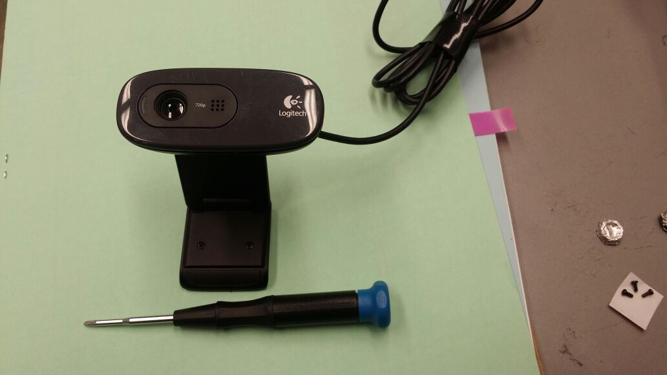 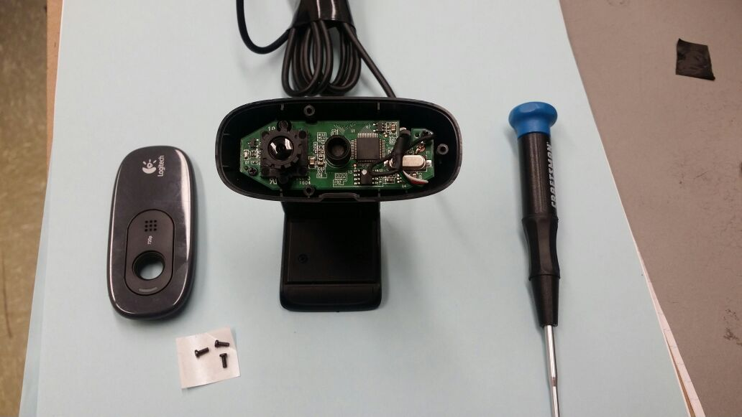

**GLUE**

Sometimes in the back of the lenses there is a tiny (but very strong) piece of glue. You need to remove it using something very small like a needle. We did it with a hairpin!!

Gently unscrew counterclockwise the camera lens. Now you can finally see the (super tiny) CMOS sensor!

To block ambient light from reaching the CMOS sensor it is necessary to shield it with an

aluminium sheet (I know doing it is very annoying..) and then add a piece of electrical black tape.

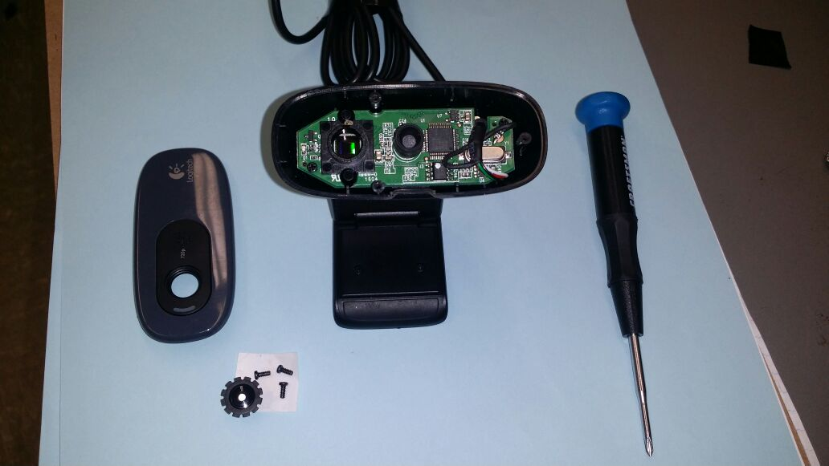 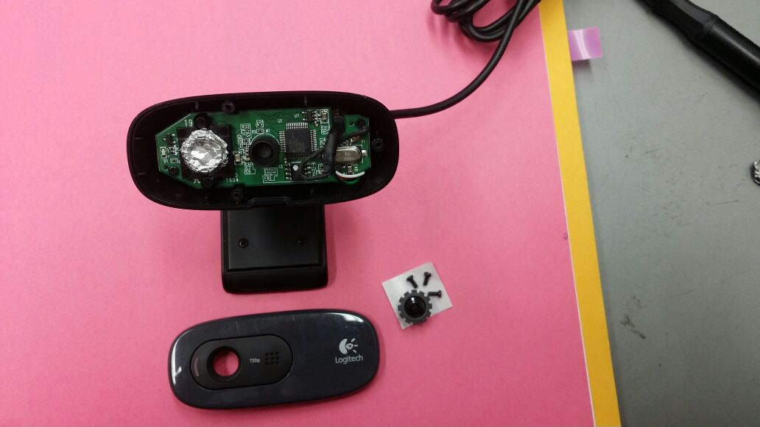

**LED**

We also removed the LED on the left side of the camera in order to avoid any kind of noise.

You can now reconnect your webcam to your Raspberry Pi.

Now your webcam is ready to detect particles!!!

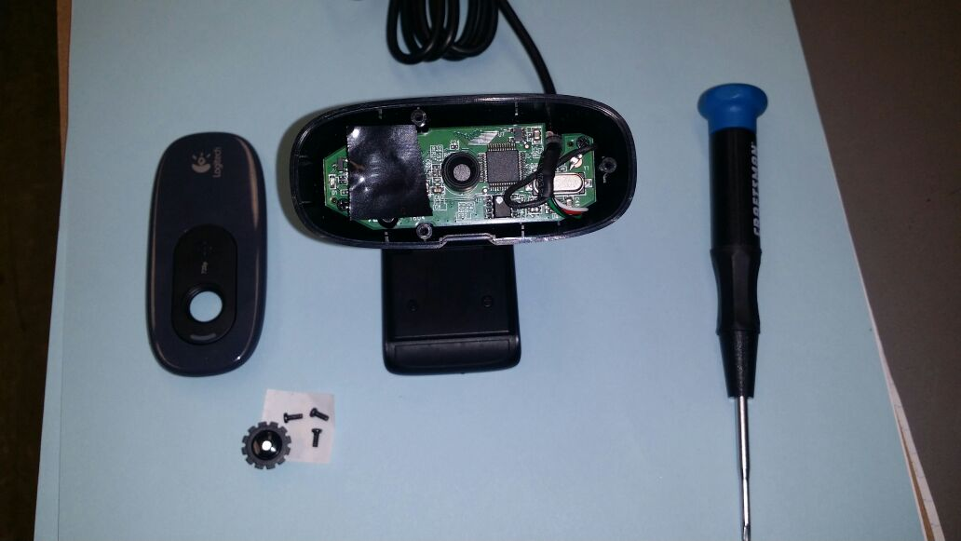 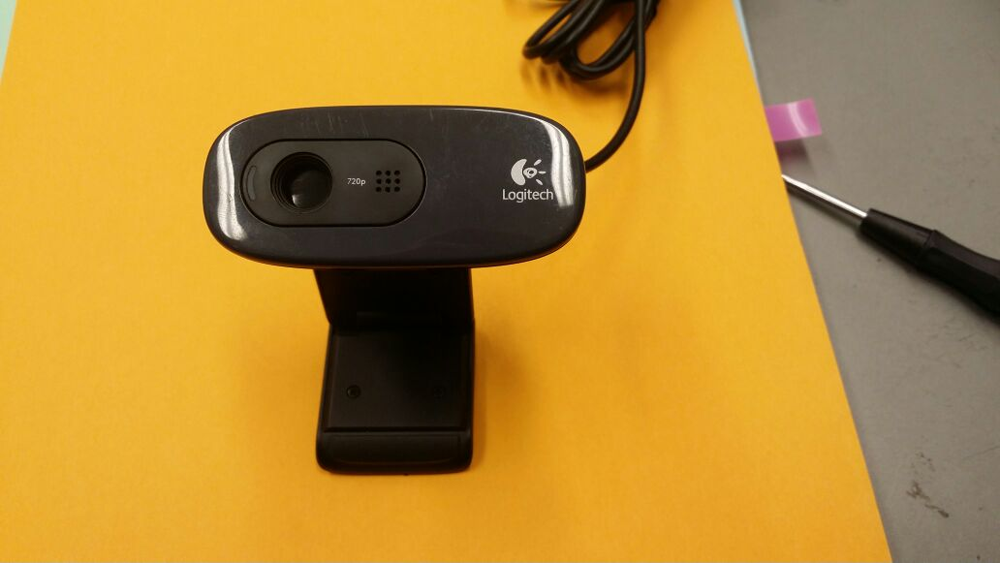

(You can always go back to the original setup if you just need to take nice pictures!)

**Setting up the GPS:** In order to know where our experiments are done we need something to track our position…!

Connect the USB cable to USB Hub. Wait for the GPS led to blink (it means it has fixed on the satellites).

To check if it works insert the following command:

LXTerminal: stty –F/dev/ttyUSB0 9600 cs8 –parenb

(this command will set the baud rate options for the gps to 9600.)

LXTerminal: cat /dev/ttyUSB0

(if everything is ok it will print the list of GPS information –NMEA sentences- until you stop it.)

To stop the stream of information press CTRL+C.

If you want to use a GPS with a bigger antenna, you can use the GPS module we used in the Part 2.

**Install Exiftool:** Our code uses this tool to modify the Exif data of the Images.

LXTerminal: sudo apt-get install libimage-exiftool-perl

Yes

Exiftool is now installed. To test it type:

LXTerminal: exiftool image_name.jpg

You can see the list of the EXIF tags of the image.

**Setting Up the Breadboard:**

First of all you need to connect the Ribbon cable to Raspberry, then connect the Cobbler to breadboard in the position you prefer (we choose the top), connect cable to cobbler. Be sure to connect it in the right way so that the GPIO pins numbers in Raspberry Board coincide with the GPIO pins numbers in the cobbler!! (usually there is a white stripe in the ribbon that goes to the 3.3V to indicate which is the right way!)

Connect the other components (when Raspberry is off ).

(Remember to connect each component to GND!)

Brown wire: from GND to the Negative row. (Remember that all holes in this row are connected)

Green Led:

-Green wire from Gpio 17 to the positive of green Led.

-Resistor1 from the negative of Led to GND row.

Red Led:

-Red wire from Gpio 5 to the positive of red Led.

-Resistor2 from the negative of Led to GND row.

Switch Button:

-Blue wire from Gpio 22 to one pin of the button.

-Grey wire from the second pin of the button to GND row.

(The numbers of GPIO are assigned –for example 22 for the button- but you can always choose to modify whatever you want! If you do, remember to change that port number in the code!!)

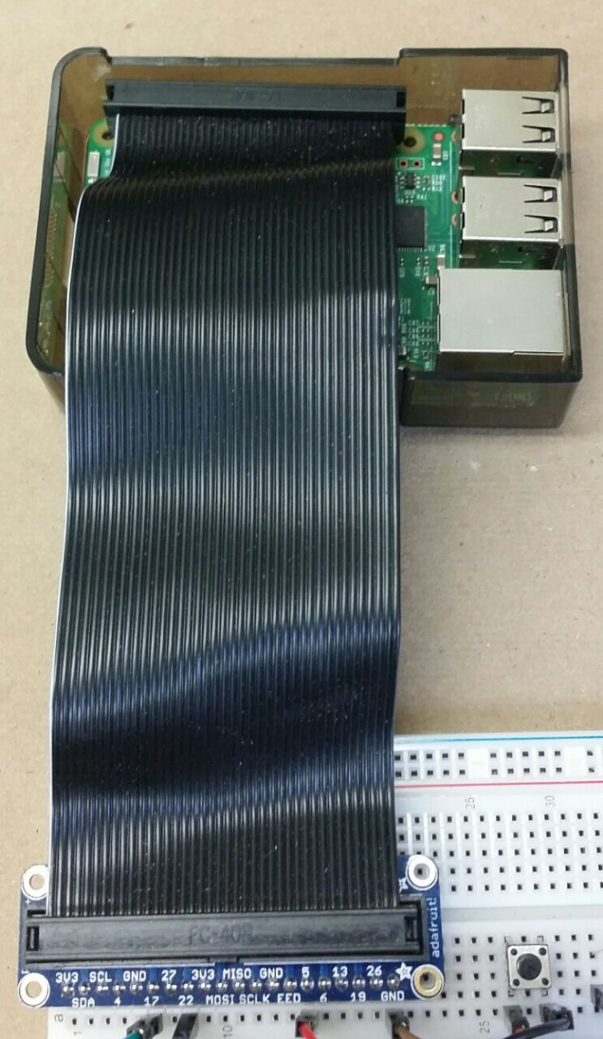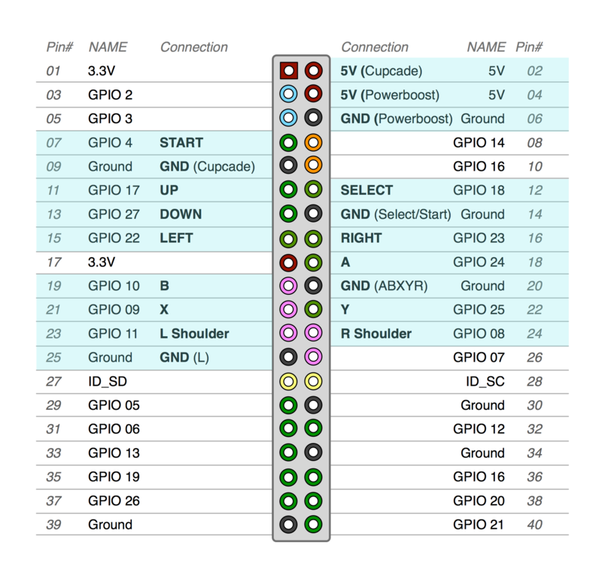

**COBBLER**

**RIBBON CABLE**

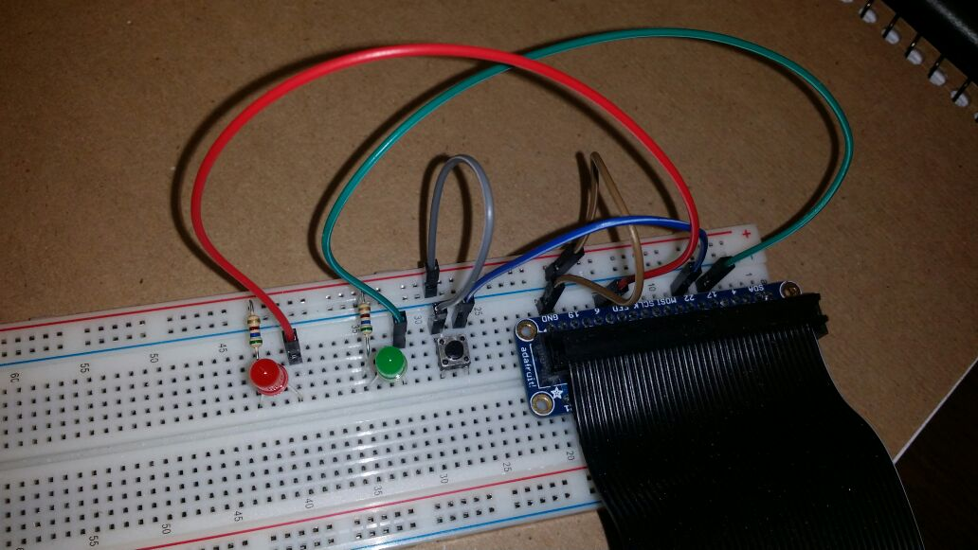

**GND ROW**

**Using the Code:**

The code we wrote in Python is called **particledetectorGM.py**

Download this code from the website LINK

Put it in a USB pen, insert the pen in Raspberry. Save the code in the main directory /**home/pi/**.

You are going to use the code by typing simple commands in the LXTerminal so before doing it, we suggest you to study some stuff about LXT and feel comfortable with it.

The following commands are our most commonly used commands (like going around the directories of your system), but you can find more in:

https://en.wikibooks.org/wiki/Guide_to_Unix/Commands/File_System_Utilities

**cd**  to change the **c**urrent **d**irectory of the shell. This current directory will be used by other programs launched from the shell.   
Eg: **cd /home/pi/** to move inside the /pi directory.

**cd ..** to change to parent directory.

**ls**  is a utility for listing the files of the current directory.

**ctrl+c** to forcibly interrupt a program.

**cat filename.txt** to see the content of the file.

**sudo** to give the administrator permission before any command.

**exit** to exit from the terminal.

First of all make sure the code **particledetectorGM.py** is in the same directory as the one in which the shell is located. (Otherwise use the cd command to navigate to the proper directory!!)

Usually you have no problems if you leave your python code in pi directory and you can just open the Lxterminal and type:

**python particledetectorGM.py**

Press Enter.

The program will start, the green and the red LEDs will switch on.

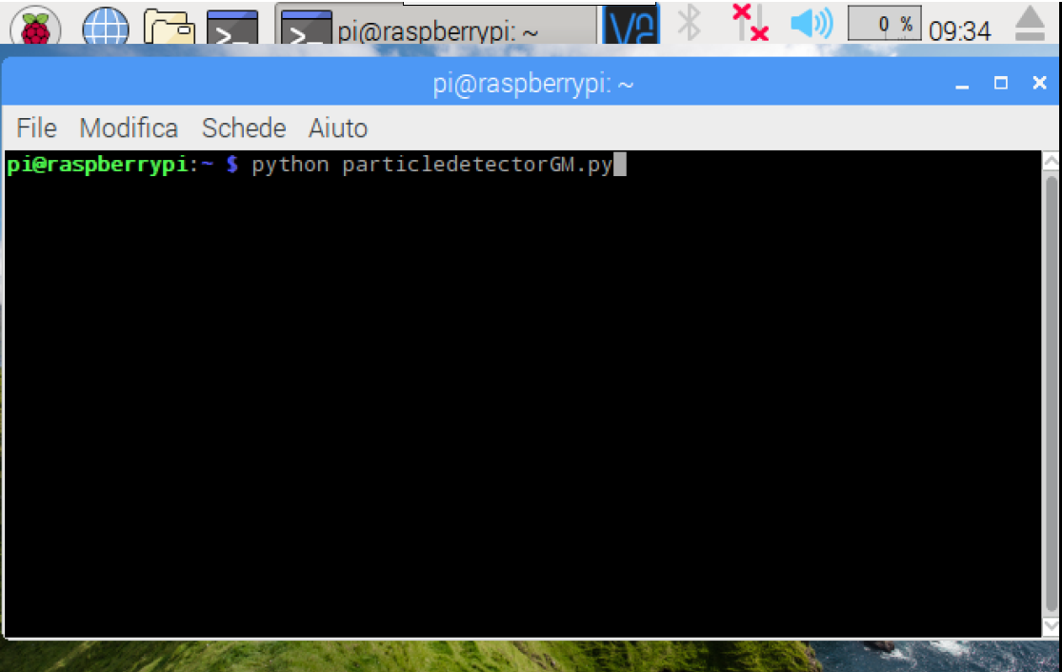

You can wait for the GPS to get a fix with the satellites (the GPS led starts to blink) or you can press the button on the breadboard to start the detection without waiting for the GPS to be ready. Depending on what you decide the red led acts differently (if you press the button the led will blinks to tell you that the program received the signal from the button).

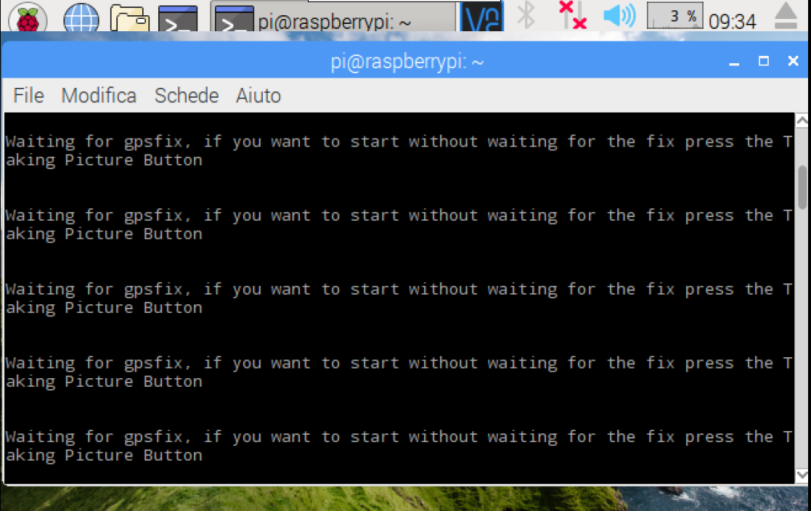

As soon as the button is pressed or the GPS is fixed, the red led switches off and the program outputs the starting time.

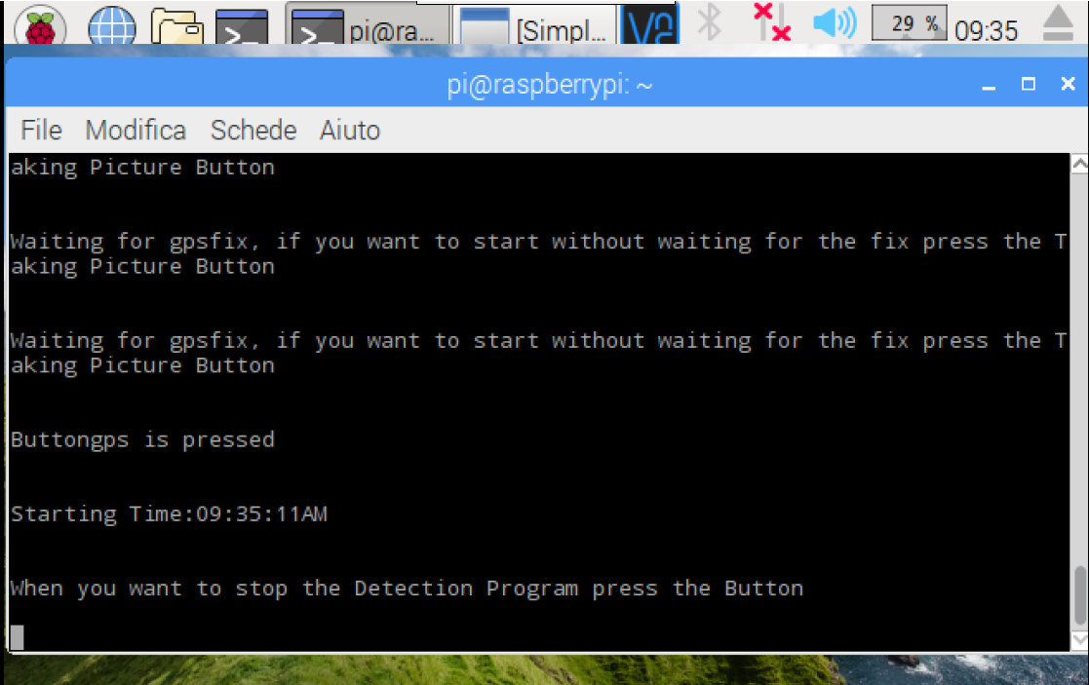

You can also see that the SimpleCV window appears, this is where the final frames you take with the camera are shown.

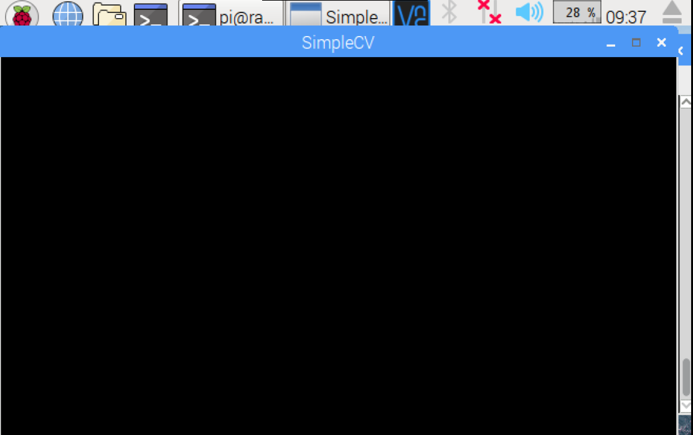

To stop the program just press the button again and make sure that the green led blinks (this tells you that the program received the input from the button). As soon as the button is pressed you will see in the screen the stopping time and the program starts to count the particles of the final frame.

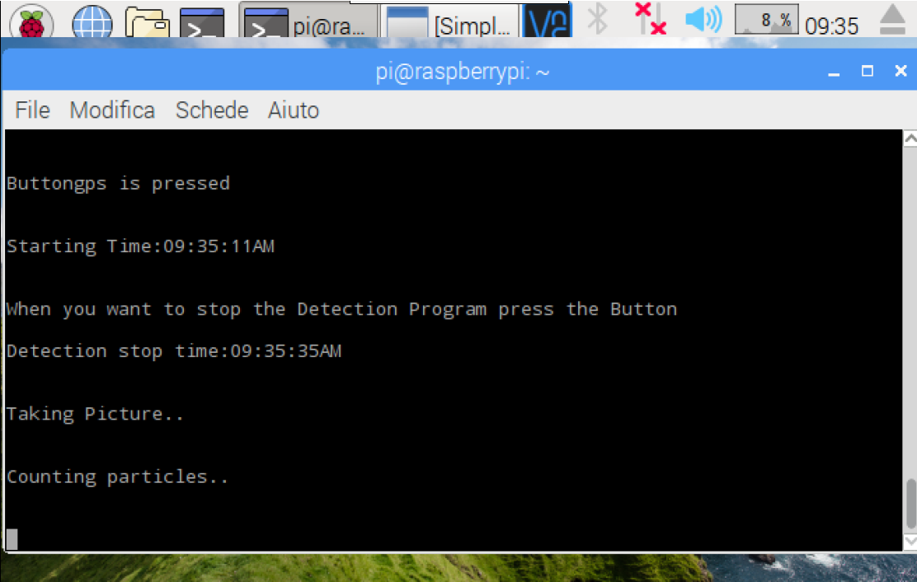

At the end it shows the number of particles detected, the GPS information and the EXIF data attached to the frame.

GPS information’s:

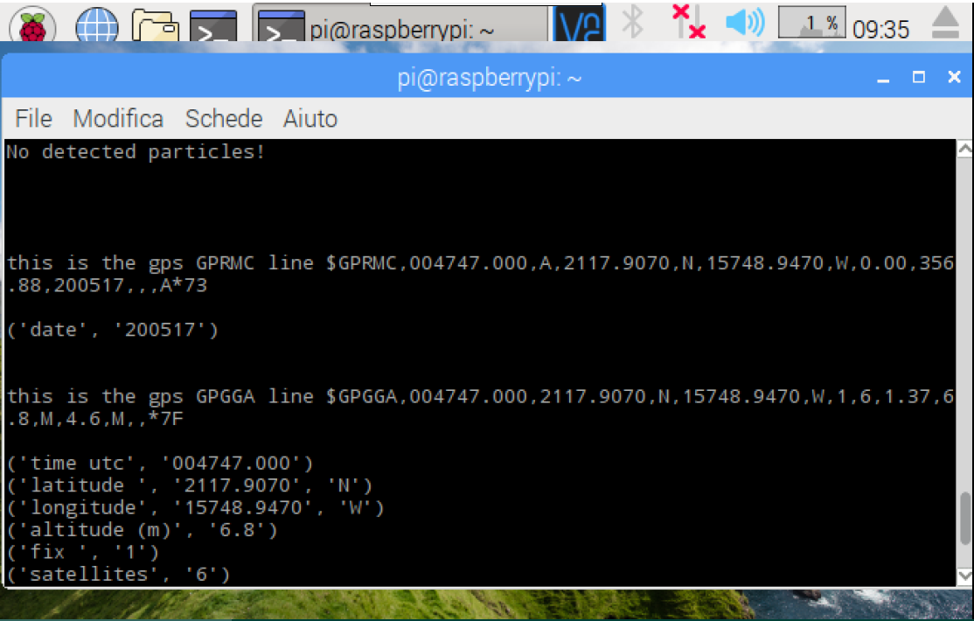

EXIF data:

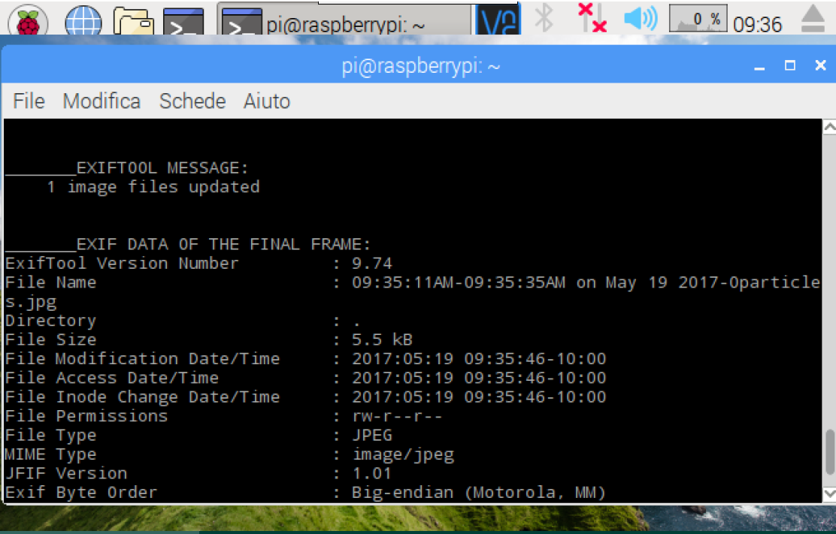

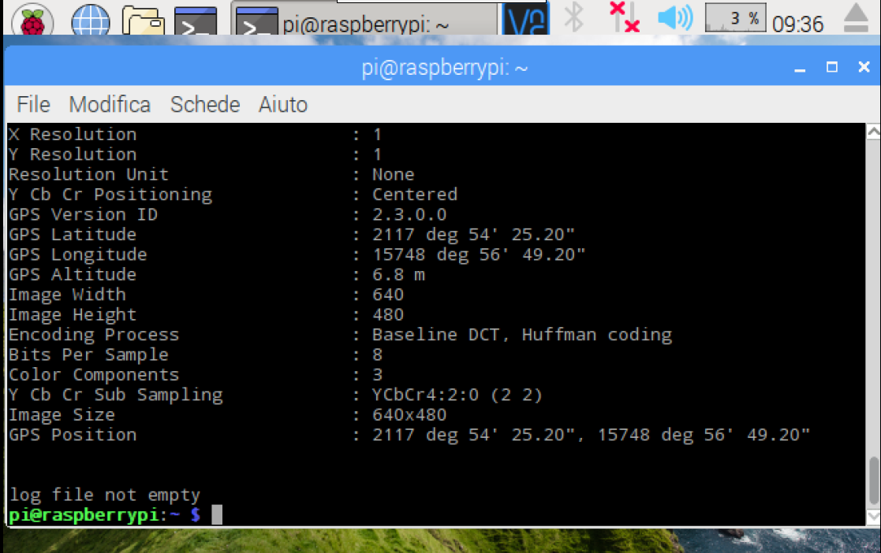

**Gps data**

The last line tells if the log file was already existing or not.

Now that the program has stopped you can see the final frame with the result of what you detected, and the logfile.csv in which you can read all the information, in the Pi directory.

This is the schema of how the **LEDs are blinking** during the stages of the program:

Start program

GPS Searching for fix Fix Found

Fix not Found. Waiting for Button Press

If Button is pressed

Taking Picture/Searching for Particles

Stop Taking Picture Button is Pressed

Counting Particles

If Founded 0 Particles

If Founded >0 Particles

If GPS data is not saved

END

**RASPBERRY AS AN ACCESS POINT**

If you want to make your Raspberry PORTABLE WHEN YOU DON’T HAVE AN AVAILABLE WIFI CONNECTION you will need to use it as an Access Point.

It means you are going to change the Wi-Fi configuration, in order to make possible to control Raspberry with ANY device that can use Wi-Fi. (This is the Headless mode: when you cannot use your monitor and keyboard, you can use your smartphone! Easy!)

To set it up we just followed the steps indicated in the official website of Raspberry:

<https://www.raspberrypi.org/documentation/configuration/wireless/access-point.md>

Anyway those are…

As always check that what you are writing is correct!! ;)

NOTE THAT AFTER THIS CONFIGURATION RASPBERRY WILL NOT BE ABLE TO CONNECT TO INTERNET WITHOUT ETHERNET CABLE!! (or you have to make a bridge…)

[This means that Raspberry will not be able to update the current date. If you need to change it, do it manually and insert this command. Modify the date as you need!!

LXTerminal: sudo date –s “Mon May 29 12:25:41 UTC 2017”

]

First of all ensure that your Raspberry Pi is updated.

LXTerminal: sudo apt-get update

LXTerminal: sudo apt-get dist-upgrade

Install all the required software with this command:

LXTerminal: sudo apt-get install dnsmasq hostapd

Yes.

Since the configuration files are not ready yet, turn the new software off as follows:

LXTerminal: sudo systemctl stop dnsmasq

LXTerminal: sudo systemctl stop hostapd

**CONFIGURING A STATIC IP**

Raspberry Pi needs to have a static IP address assigned to the wireless port.

This documentation assumes that we are using the standard 192.168.x.x IP addresses for our wireless network, so we will assign the server the IP address 192.168.0.1. It is also assumed that the wireless device being used is wlan0.

First, the standard interface handling for wlan0 needs to be disabled. Normally the dhcpd daemon will search the network for another DHCP server to assign a IP address to wlan0. This is disabled by editing the configuration file:

LXTerminal: sudo nano /etc/dhcpcd.conf

Add

*denyinterfaces wlan0*

to the end of the file (but above any other added interface lines) and save the file and exit.

To configure the static IP address, edit the interfaces configuration file with:

LXTerminal: sudo nano /etc/network/interfaces

Find the wlan0 section and edit it so that it looks like the following:

allow-hotplug wlan0

iface wlan0 inet static

address 192.168.0.1

netmask 255.255.255.0

network 192.168.0.0

Instead of erasing the stuff that we don’t want, just comment it with # at the beginning of every sentence. Save and Exit.

Now you will restart the dhcpcd daemon and set up the new wlan0 configuration:

LXTerminal: sudo service dhcpcd restart

LXTerminal: sudo ifdown wlan0

LXTerminal: sudo ifup wlan0

**CONFIGURING THE DHCP SERVER (DNSMASQ)**

You are now going to rename the dnsmasq configuration file, and edit a new one:

LXTerminal: sudo mv /etc/dnsmasq.conf /etc/dnsmasq.conf.orig

LXTerminal: sudo nano /etc/dnsmasq.conf

Type or copy the following information into the dnsmasq configuration file and save it:

interface=wlan0 ( Use the require wireless interface - usually wlan0!!!)

dhcp-range=192.168.0.2,192.168.0.20,255.255.255.0,24h

Save and Exit.

So for wlan0, we are going to provide IP addresses between 192.168.0.2 and 192.168.0.20, with a lease time of 24 hours. If you are providing DHCP services for other network devices (e.g. eth0), you could add more sections with the appropriate interface header, with the range of addresses you intend to provide to that interface.

**CONFIGURING THE ACCESS POINT HOST SOFTWARE (HOSTAPD)**

You need to edit the hostapd configuration file, to add the various parameters for your wireless network. After initial install, this will be a new/empty file.

LXTerminal: sudo nano /etc/hostapd/hostapd.conf

Add the information below to the configuration file. This configuration assumes we are using channel 7, with a network name of Pi-AP, and a password Yourpassword. Note that the name and password should **not** have quotes around them.

interface=wlan0

driver=nl80211

ssid=Pi-AP

hw_mode=g

channel=7

wmm_enabled=0

macaddr_acl=0

auth_algs=1

ignore_broadcast_ssid=0

wpa=2

wpa_passphrase=Yourpassword

wpa_key_mgmt=WPA-PSK

wpa_pairwise=TKIP

rsn_pairwise=CCMP

Save and Exit.

We now need to tell the system where to find this configuration file.

LXTerminal: sudo nano /etc/default/hostapd

Find the line with #DAEMON_CONF, and replace it with this:

DAEMON_CONF="/etc/hostapd/hostapd.conf"

Save and Exit

**START IT UP**

Now start up the remaining services:

LXTerminal: sudo service hostapd start

LXTerminal: sudo service dnsmasq start

Using a wireless device (your smartphone!), search for Wi-Fi networks. The network SSID should now be present, and it should be accessible with the specified password.

If SSH is enabled on the Raspberry Pi access point, it should be possible to connect to it from another Linux box (or a system with SSH connectivity present) as follows, assuming the pi account is present:

ssh [pi@192.168.0.1](mailto:pi@192.168.0.1)

By this point, the Raspberry Pi is acting as an access point, and other devices can associate with it.

Using it like an **Access Point:**Switch on RSB (SW3). Find VNC Viewer in the Start Panel/Internet

Go to Start Panel/Preferences/Raspberry Pi Configuration / ENABLE VNC.

Switch on the other device (ex Phone): Download VNC viewer from https://www.realvnc.com/download/viewer/.

Connect via Wi-Fi to the Raspberry connection (Pi-AP) (password: Yourpassword).

Open VNC insert Raspberry IP (we configured 192.168.0.1).

VNC will ask for RSB username and password (pi, raspberry-or whichever password you entered before).

Use Phone to control the Raspberry Pi as you would use the keyboard, mouse, and monitor.

**IF YOU WANT TO ADD SENSORS TO THIS DETECTOR, FOLLOW THIS PART**

**Part 2: Improvement of the particle detector**

**INSTALLING THE BUZZER**

If you want your particle detector to emit a sound when a particle is detected, you can! To do that, we can use a buzzer.

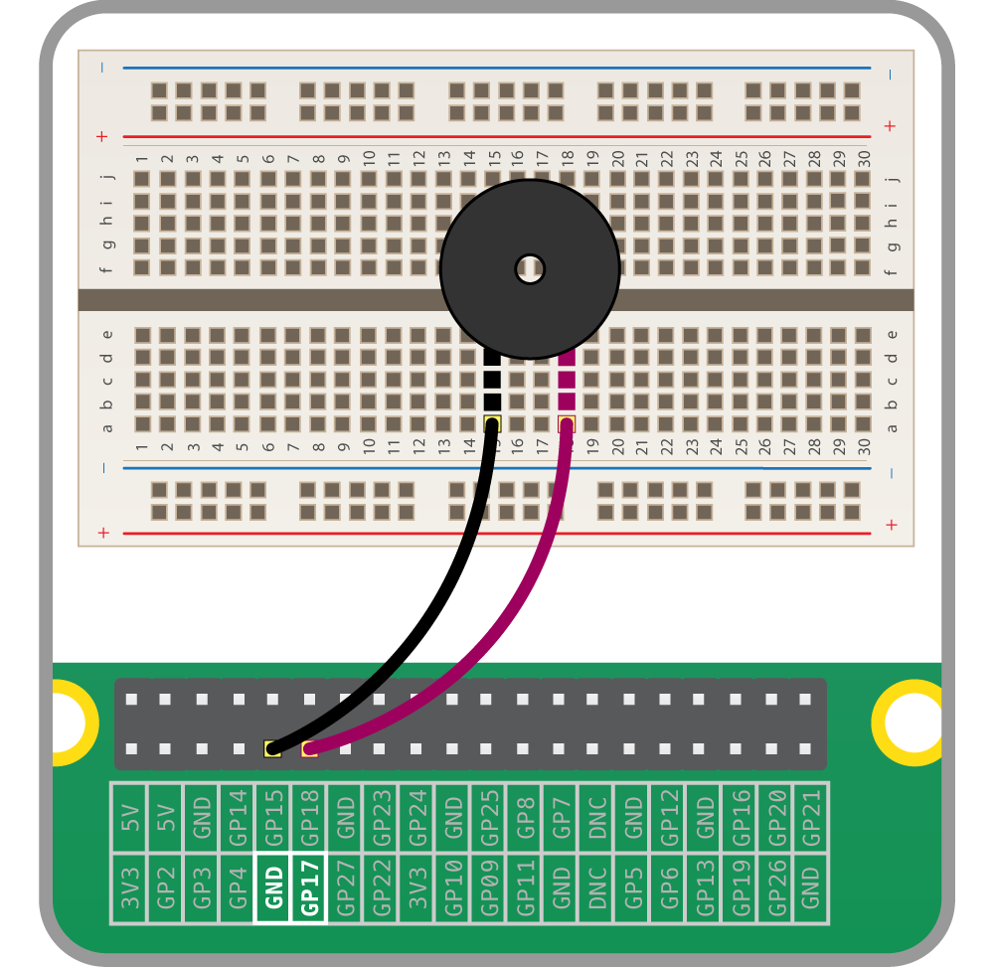To connect it to the Raspberry Pi, you have to put the buzzer on the breadboard. Normally, you should see a positive sign on the top of the buzzer. You have to connect the + pin to the GPIO (I personally chose pin 25), and the other one to the ground (GND). Remember that you can choose the pin you want, but don’t forget you have to change it in the code!

Now, your buzzer is connected. Everything you have to do is to write the code to use it.

**INSTALLING THE ULTIMATE GPS BREAKOUT**

The Ultimate GPS Breakout from Adafruit has a huge external antenna, which allows us to have fix inside a building. To set up this GPS, please follow these steps:

1. **Connection to the Raspberry Pi**

You have two different ways to connect your GPS. You can use the easiest way, using an inexpensive USB to TTL (Male) cable with your GPS module. Or, you can use the UART method, which consist in directly connecting the GPS to the breadboard with jumper wires.

In this project, I used the UART method, because I didn’t have a USB to TTL cable. If you want to learn the easiest way, please follow this tutorial on Adafruit website:

<https://learn.adafruit.com/adafruit-ultimate-gps-on-the-raspberry-pi/setting-everything-up>

**If you choose the UART method, follow this:**

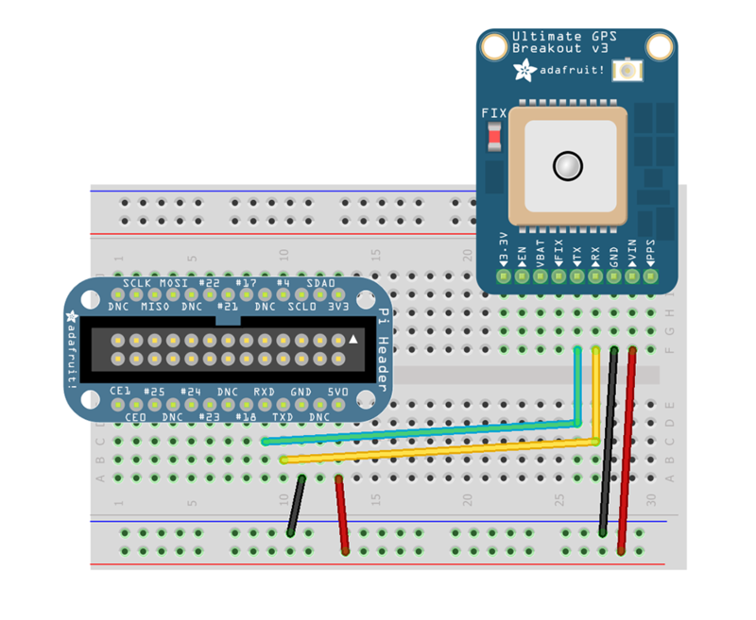To connect your GPS module to the Pi, you have to connect only 4 pins (Vin, GND, RX and TX)

**As you can see, you have to cross the TX and RX pins, connecting RX to TXD and TX to RXD!**

1. **Allowing UART method**

As you are connected with UART, you have to allow the Raspberry Pi to connect like this.

Enter the command line:

$ sudo nano /boot/cmdline.txt

And here you have to modify the file, removing console=ttyAMA0,115200 and kgdboc=ttyAMA0,115200 if present).

1. **Installing gpsd**

This software will understand the serial data that your GPS is providing.

To install gpsd, run the following commands:

$ sudo apt-get install gpsd gpsd-clients python-gps

This will install the required packages. Don’t remember that you have to be connected to the Internet to install a package!

1. **Getting data**

For the **Raspberry Pi 3** you need to use the **/dev/ttyS0** port since that is what is normally connected to the GPIO serial port pins.  Use these two commands instead:

$ sudo systemctl stop serial-getty@ttyS0.service

$ sudo systemctl disable serial-getty@ttyS0.service

Then, you have to explicitly enable the serial port on the GPIO pins.

Run the following command:

$ sudo nano /boot/config.txt

And at the bottom of the file, you can enable the UART writing:

enable_uart=1

Press Ctrl-O to save, then enter, and Ctrl-X to come back on the main terminal.

Reboot your Raspberry Pi:

$ sudo reboot

To use the serial port, run:

$ sudo killall gpsd

$ sudo gpsd /dev/ttyS0 -F /var/run/gpsd.sock

And to finish, to display the data, run:

$ cpgs –s

This command didn’t work for me. If you know you have a fix (the red LED of the GPS is blinking every 15 seconds), and this command is not working for you too. Just try:

$ gpsmon /dev/ttyS0

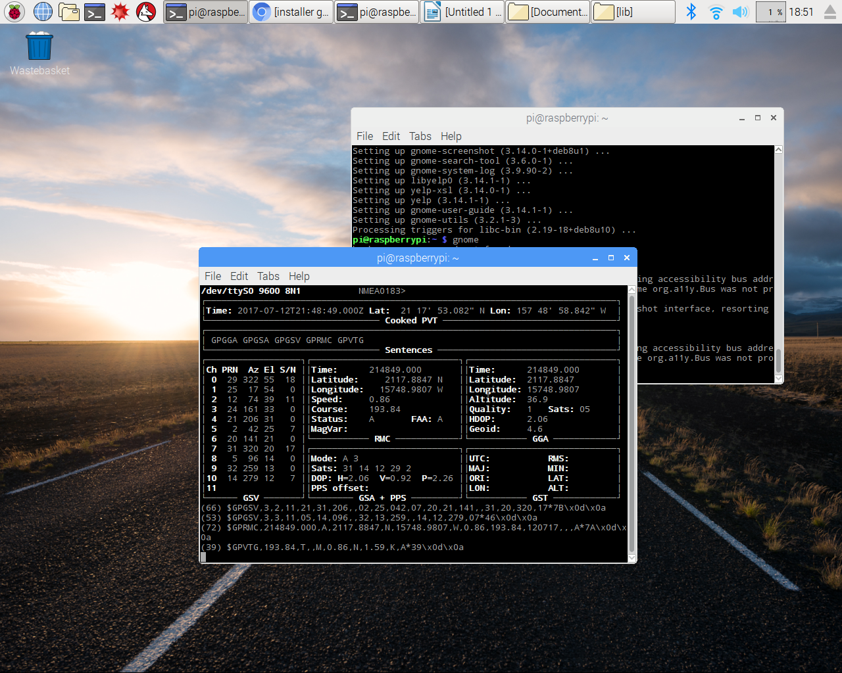

You should have this kind of display, with all the data. If nothing happens, please do it again. Check that all the packages have been correctly installed. Then, to use it, you just have to replace the using serial port in the code. Remove **/dev/ttyUSB0**, because we are not using the webcam anymore, and replace it by the new serial port, **/dev/ttyS0**.

**INSTALLING THE PRESSURE + TEMPERATURE SENSOR (BMP180)**

We can also add a pressure and a temperature sensor on this particle detector, in order to get more parameters on each event. Instead of using two different sensors, one for the temperature, and another one for the pressure, I found this sensor, called BMP180 from the company Bosch, which is reliable and inexpensive. It acts like a barometer and can be used in many projects.

To connect it to the breadboard, you have to connect 4 pins to the GPIO (Vin, SCL, SDA and GND). **To get a better connection, I advise you to solder your BMP180 on pins**.

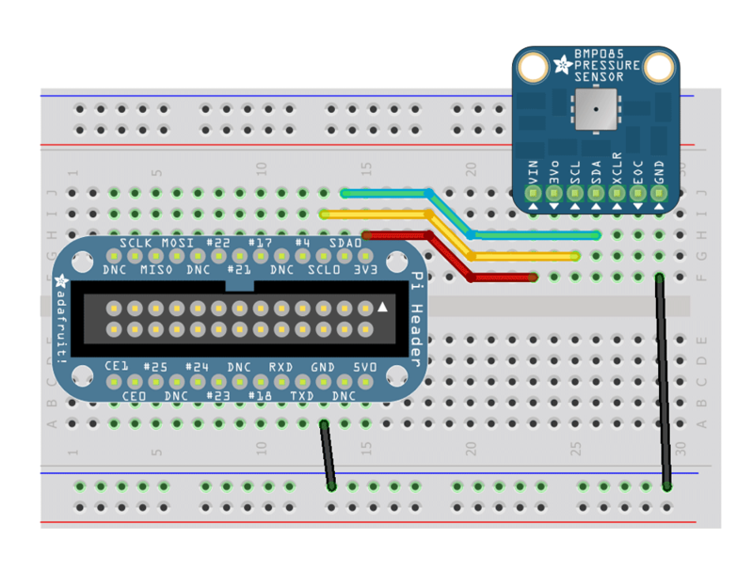For the connection, you can do as the following:

Be careful, Vin has to be connected to **3v3**, not 5V! The sensor will not appreciate if you give its 5V.

Now, you have to configure the Pi to I2C.

**WHAT IS I2C ?**

I2C means Inter-Integrated Circuit. It is typically used for attaching lower-speed peripheral [ICs](https://en.wikipedia.org/wiki/Integrated_circuit) to processors and [microcontrollers](https://en.wikipedia.org/wiki/Microcontroller" \o "Microcontroller) in short-distance, intra-board communication. For this, we have 2 new parameters, called SDA and SCL. SDA is used for the bi-direction data, and SCL represents the clock signal.

**CONFIGURING I2C**

To configure I2C, you have to install the i2c-tools utility. Run the following commands in your terminal:

$ sudo apt-get install –y python-smbus

$ sudo apt-get install –y i2c-tools

When the installation is done, go in the main menu of your Raspberry Pi (click on the Raspberry), then Preferences/Raspberry Pi Configuration/Interfaces and here, make sure that I2C is **ENABLED**. If I2C is disabled, enable it.

Then, reboot you Pi 🡺 $ sudo reboot

Now, you have to install Kernel Support. Run the following commands in your LXTerminal:

$ sudo nano /etc/modules

And add these two lines at the bottom of the file:

i2c-bcm2708

i2c-dev

Ctrl-O to save, enter, and Ctrl-X to come back to the main menu.

To be sure these two lines are not in your blacklist, please go in your blacklist:

**$ sudo nano /etc/modprobe.d/raspi-blacklist.conf**

**And if you see:**

blacklist spi-bcm2708

blacklist i2c-bcm2708

Please comment! (Put a # in front of them). Otherwise, your I2C won’t be configure.

Then, do:

$ sudo nano /boot/config.txt

And add the text:

**dtparam=i2c1=on (NOTE: this is a one, not an “L”)  
dtparam=i2c_arm=on**

Reboot you Pi.

**TESTING I2C**

Now we will see if everything is working. In your LXTerminal, run the following command line:

$ sudo i2cdetect –y 1

This is it. If you see a number written in these lines, then your BMP180 is detected. Basically, you should see a 77 in the latest position.

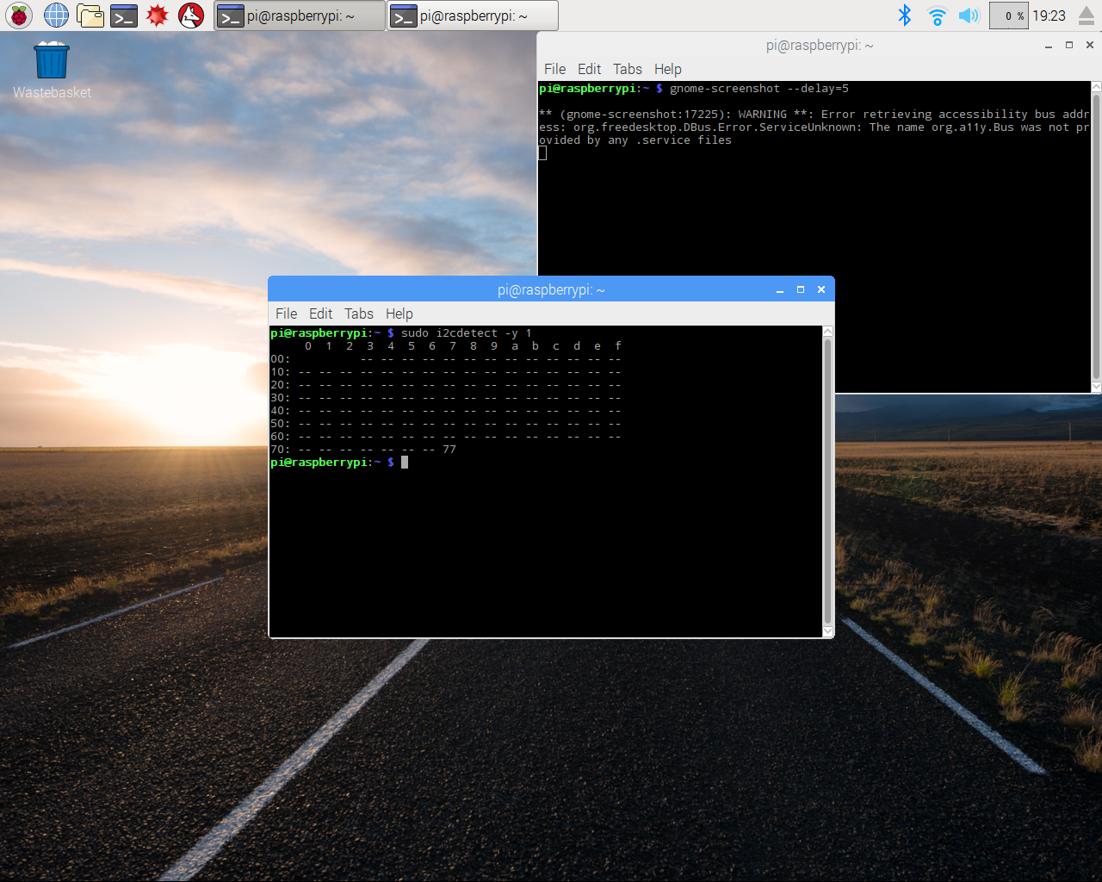

Now we can install the libraries we need to run the BMP. Run these commands in the Terminal:

$ sudo apt-get update

$ sudo apt-get install git build-essential python-dev python-smbus

$ git clone https://github.com/adafruit/Adafruit_Python_BMP.git

$ cd Adafruit_Python_BMP

$ sudo python setup.py install

$ cd examples

$ sudo python simpletest.py

Here you are running a simple test which will allow you to see if your BMP180 is working. Some data should appear. If you receive an error message, carefully check that the library was installed correctly in the previous steps and try again.

**INSTALLING THE DISPLAY SCREEN**

We chose to use a 128x32 monochrome display screen from Adafruit. The idea is to display the number of particles we detected during an experiment, and we can also display pressure, altitude, temperature. You can display what you want.

To connect the monochrome display screen to the Raspberry Pi, you can follow the next steps.

First of all, this component also uses I2C, like BMP180, as seen above. So you will find again the pins SDA and SCL.

Connect the Vin pin to 5V on the GPIO header, and the ground to GND. The RST pin allows the Raspberry to know at which pin your display is connected. So, you can choose to connect the RST pin where you wish. I personally chose pin 24. To finish the installation, connect the SDA and SCL pins as we did before for the pressure sensor. **DO NOT CONNECT THE 3V3 PIN!**

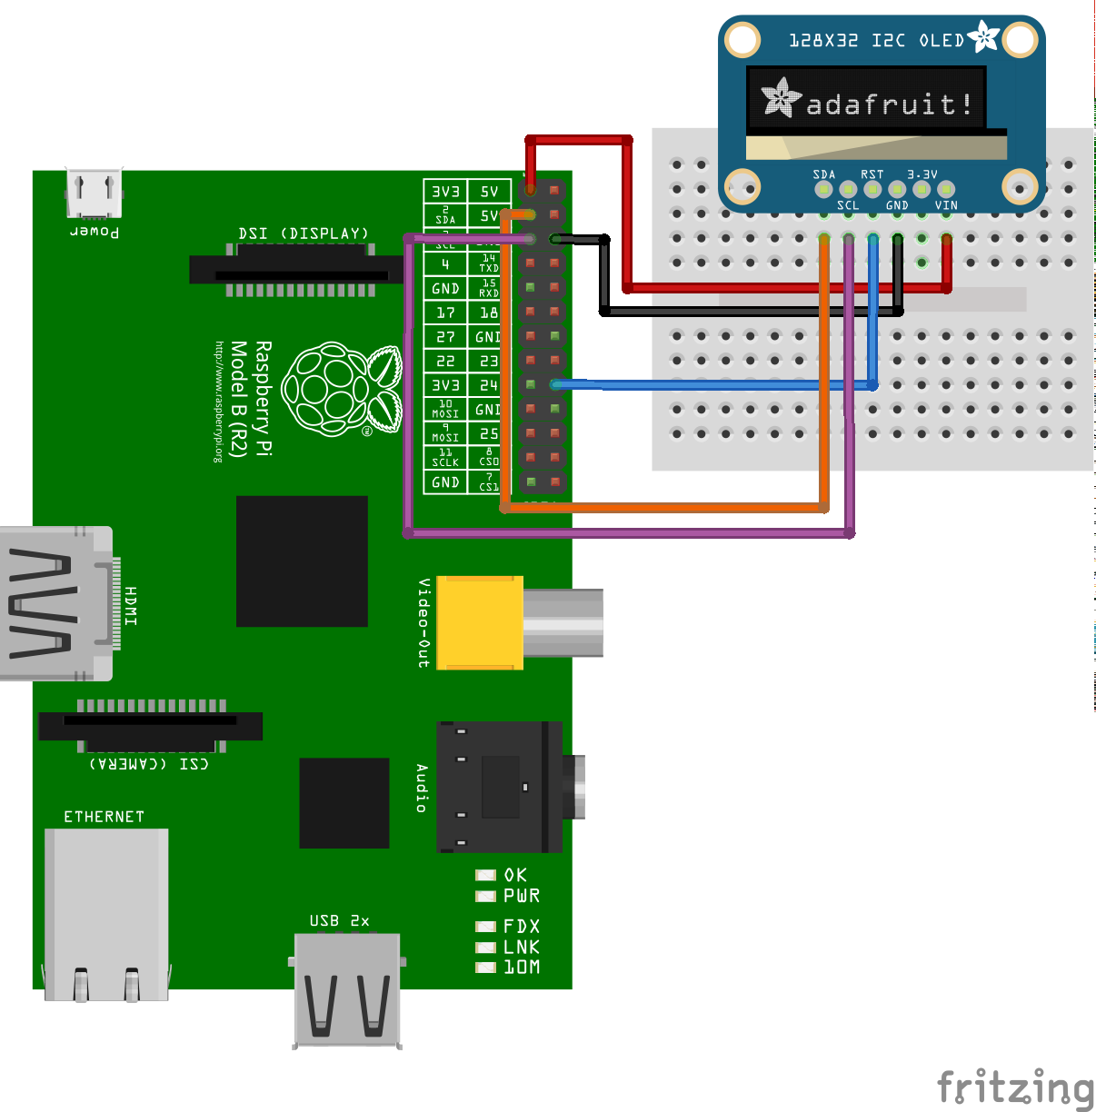

Then, you need to install some libraries. Do as following:

$ sudo apt-get update  
$ sudo apt-get install build-essential python-dev python-pip

$ sudo apt-get install python-imaging python-smbus

Now, you need to download and to install the SSD1306 python library, with one you will have very useful examples to see if everything is working fine.

$ sudo apt-get install git  
$ git clone <https://github.com/adafruit/Adafruit_Python_SSD1306.git>  
$ cd Adafruit_Python_SSD1306  
$ sudo python setup.py install

To check if your display screen works, you can run an example, and see if your screen is able to display it.

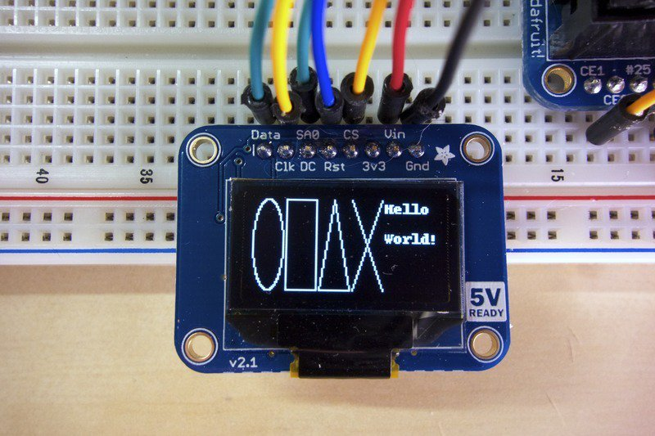$ cd Adafruit_Python_SSD1306

$ cd examples

$ python shapes.py

By running this example, you should see something like this:

If it is working, then you can take note about the code, how it works, and begin to have fun!

**NOTE THAT THE CODE IS NOT THE SAME AS THE BEGINNING OF THIS TUTORIAL! IF YOU ADDED SENSORS, PLEASE RUN THE ParticleDetectorImproved.py PYTHON CODE!**